Kanokphan Sirithienthong
Student ID: 6610750092

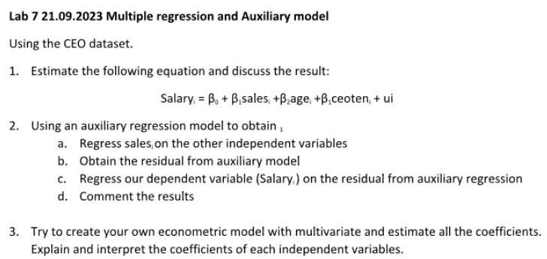
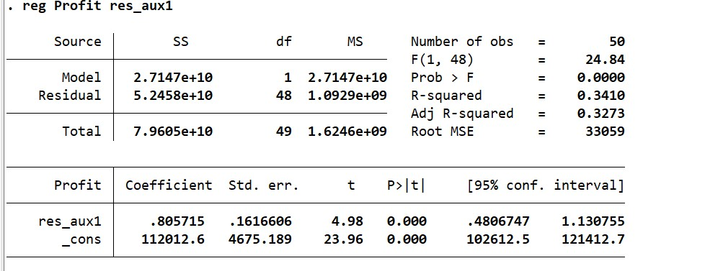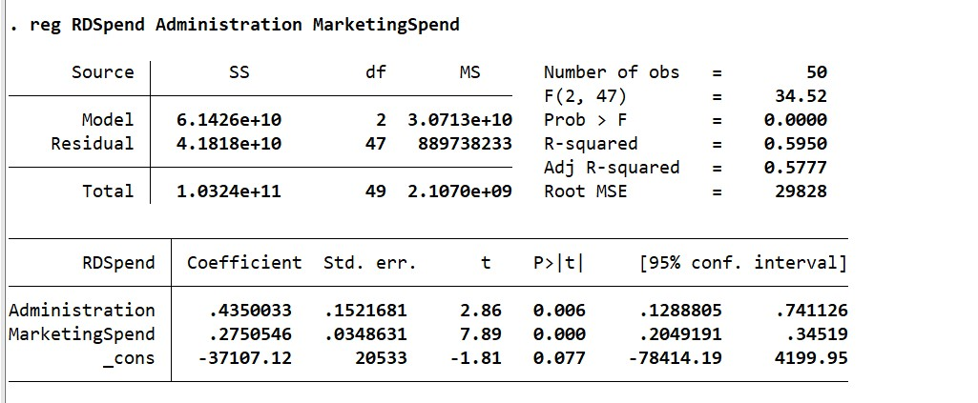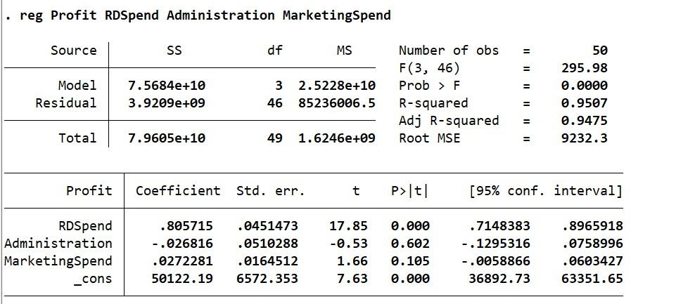

Problem 1: Multiple Regression
Dependent variable (Y): Profit Independent variables: R&D Spend, Administration, Marketing Spend
- R-squared = 0.9507 → The model explains 95.07% of the variation in Profit, indicating excellent fit.
R&D Spend
- One unit increase in R&D Spend raises Profit by 0.806 units.
- Very significant (t = 17.52).
- Strongest predictor of Profit.
Administration
- Coefficient is negative and not significant (t = -0.51).
- No meaningful impact on Profit.
Marketing Spend
- Positive effect but not statistically significant (t = 1.53).
- Weak predictor in this model.

Problem 2: Auxiliary Regression
Step 1: Regress R&D Spend on Administration and Marketing Spend
- R-squared = 0.595 → Moderate explanatory power.
- Both predictors are significant.
Step 2: Extract residuals (res_aux1)
- Captures variation in R&D Spend unexplained by other variables.
Step 3: Regress Profit on res_aux1
- Coefficient = 0.8571, highly significant (t = 4.98).
- R-squared = 0.341 → Residuals explain 34.1% of Profit.
Interpretation
- R&D Spend contains unique information not captured by Administration or Marketing Spend.
- Confirms its importance in explaining Profit.

Problem 3: Custom Model
Suggested model: Profit = δ₀ + δ₁·R&D Spend + δ₂·Marketing Spend + δ₃·State Dummy
- R&D Spend: Expected to remain highly significant.
- Marketing Spend: May gain significance when Administration is excluded.
- State Dummy: Adds regional context to Profit variation.
Interpretation
- Each coefficient reflects the marginal effect of its variable on Profit.
- Significance levels guide which predictors are most impactful.

